Evidence for Plate Tectonics Task

**Part 1: Continental Drift Theory**

In 1915, Alfred Wegener proposed the theory of continental drift. The theory states that the continents were once joined together as one supercontinent called Pangea and over time the continents drifted apart and separated.

Wegener based his theory on five kinds of evidence. Use the map below to explain how he used **three** types of evidence to form his conclusion.

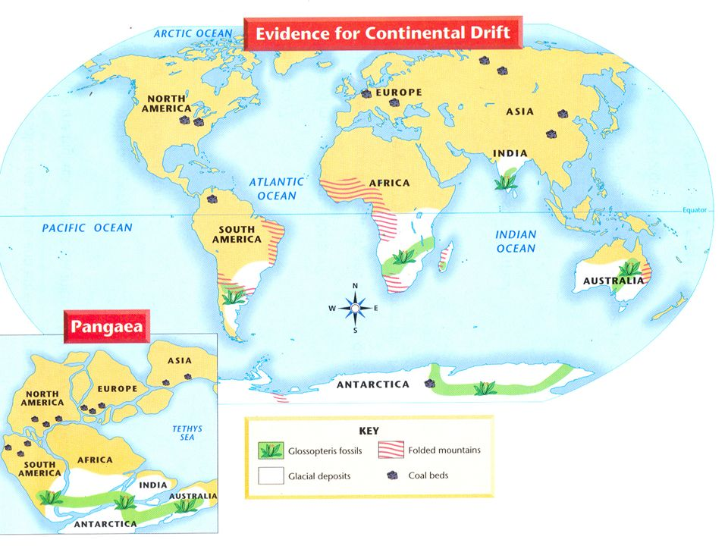

|  |  |  |
| --- | --- | --- |
| **Evidence** | **Location on Map** | **Explanation** |
|  |  |  |
|  |  |  |
|  |  |  |

**Part 2: Pioneers of Plate Tectonics**

The theory of plate tectonics has been developed over many years, with contributions from a number of scientists across different fields of science.

Use the information on the website listed below to summarise the contribution of each of the following scientists to the theory of plate tectonics.

<https://www.geolsoc.org.uk/Plate-Tectonics/Chap1-Pioneers-of-Plate-Tectonics>

|  |  |  |
| --- | --- | --- |
| **Scientist**  **(birth and death dates)** | **Date of Contribution** | **Short Description of Contribution** |
| **Harry Hess**  **( _____ - _____ )** |  |  |
| **Frederick Vine**  **( _____ - _____ )**  **and**  **Drummond Matthews**  **( _____ - _____ )** |  |  |
| **John Tuzo-Wilson**  **( _____ - _____ )** |  |  |
| **Dan McKenzie**  **( _____ - _____ )** |  |  |

**Part 3: Plate Tectonics Timeline**

Use the information from part 2 to construct a timeline to show how the theory of plate tectonics has developed over time, **starting from Wegener’s original proposal**. In your timeline, include the name of the scientist, the date and a brief statement of their contribution.